Knife cookbook create user

vim /home/ubuntu/chef-repo/cookbooks/user/recipes/default.rb

user 'ajay' do

comment 'A random user'

uid '1234'

home '/home/ajay'

shell '/bin/bash'

password 'root1234'

end

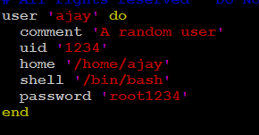

knife cookbook upload user

ssh -i /home/ubuntu/chef-repo/ibm-public-key.pem [ec2-user@ec2-52-67-119-162.sa-east-1.compute.amazonaws.com](mailto:ec2-user@ec2-52-67-119-162.sa-east-1.compute.amazonaws.com)

sudo su

chef-client

id ajay



**Creating group and adding user to the group**

vim /home/ubuntu/chef-repo/cookbooks/user/recipes/default.rb

group 'cloud' do

action :create

members 'ajay'

append true

end

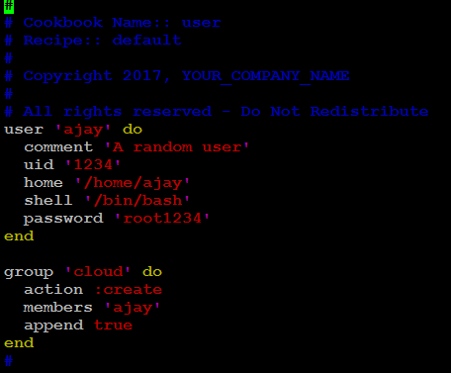

knife cookbook upload user

ssh -i /home/ubuntu/chef-repo/ibm-public-key.pem [ec2-user@ec2-52-67-119-162.sa-east-1.compute.amazonaws.com](mailto:ec2-user@ec2-52-67-119-162.sa-east-1.compute.amazonaws.com)

cat /etc/group | grep cloud



id ajay

